Fantasy Kingdoms

  - Design Documentation

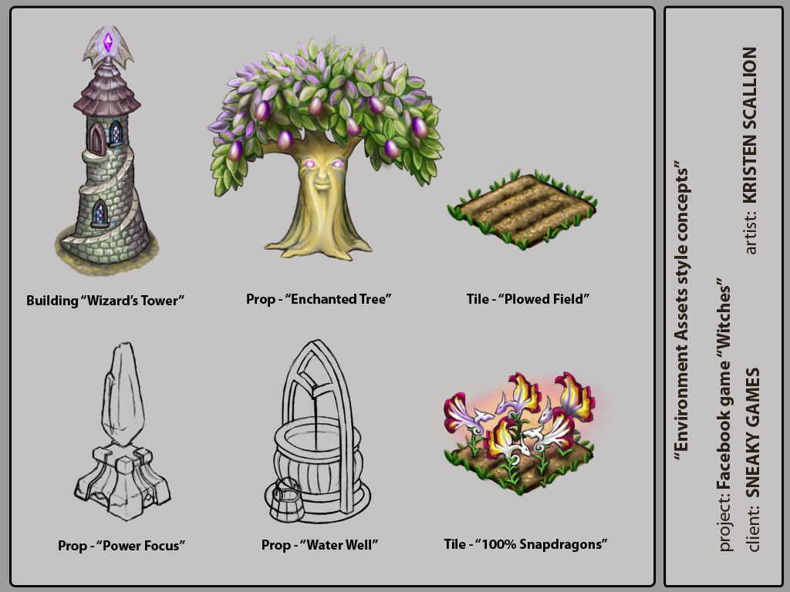

Written by Billy Cain
© 2009 Sneaky Games

Fantasy Kingdoms Design
Fantasy Kingdoms is an online, social, Kingdom-Building game that is free to play.
Contents
Backstory and Story 7
Game Play 7
Gameflow within Fantasy Kingdoms 8
Buy in-game Gold (see Premium Experience for more detail) 8
Earn Mana (see Mana for more detail) 9
Enchant Land (see Enchant for more detail) 9
Purchase Spells (see Spells for more detail) 9
Cast Spells on Enchanted Land (see Cast for more detail) 9
Plant Trees and Tree-Like Items (see Trees for more detail) 9
Grow Reagents (see Reagents for more detail) 9
Collect Reagents (see Collect for more detail) 9
Forge Crystals from Reagents (see Crystals for more detail) 10
Build and Enchant Power Items (see Power Items for more detail) 10
Purchase Castles and Castle Pieces (see Castles for more detail) 10
Premium Experience – Buy in-game Gold 10
Accelerated Advancement 10
Micro-Transactions 11
Leveling / Experience 13
Experience Points 13
Leveling up Avatar (through Kingdom-building activity) 13
Avatar Creation and Editing 13
Account Creation 13
Changing your appearance 13
Changing the name and sex of your Avatar 14
Game Basics: Main Things to do 14
Make Mana (money) quickly 15
Earn Fantasy Kingdoms Mana 15
Visit the Market 16
Spend Fantasy Kingdoms Mana in the Market 16
Visit other people's Kingdoms 16
Participate in the Daily Lottery 16
Buying Gold (see Premium Experience for more information) 16
Earning Mana 16
Building your Castle! 17
Castle Pieces 17
Enchanting Land 18
Buying and Casting Spells 18
Reagents 18
Collecting Reagents 19
List of Reagents 19
Duration of growth until time to Collect 19
Bewitched Reagents 20
Bewitching Description 20
Reagent Bewitching Time 20
Re-casting Spells after being Bewitched 20
Crystals 21
Power Items 21
Power Items that Impact Gameplay or Generate Reagents 21
Trees / Forests 22
Trees that Generate Reagents 22
Enchanting Items 22
The Market 22
Locked items in Market 23
Decorations 23
Selling items from my Kingdom 23
Misc Art Needs for Market 23
Alchemy: Crafting / Combining 24
Potions 24
(I moved this to another section on gifting)Crystals 24
Amulets 24
Wards 25
GUI 25
Border GUI – The Game View’s “Frame” 25
Play 25
Gift 25
Neighbors 26
Invite 26
Reviews 26
Forum 26
Help 26
Account 26
Mana / Cash 26
Company Logo 26
Game GUI – From Within The Game View Frame 26
Wand 26
Cauldron 27
Scythe 27
Charms 27
Market 27
Gifts 27
Neighbor bar 27
Zoom buttons 27
Camera 27
Full screen 27
Options – General Game Options 27
Music 27
Sounds Toggle 28
Preferences 28
Help 28
Charms (Trophies) 28
Neighbors 29
Adding Friends as Neighbors 29
Visiting Neighbors’ Kingdoms 29
Difference between Neighbors and Buddies 29
Limits on Neighbors 29
Buddies 30
Buddy List 30
Visiting my Buddies 30
Tending Other People’s Kingdoms 30
Random Events on Other Kingdoms 30
Cleaning up Stray Leaves with Wind Rush Spell 30
Clear up Loose Pixie Dust with Fairy Dusting Spell 31
Remove Fog / Clouds with Cloudgone Spell 31
Other ideas for Events 31
Experience Points for Tending Neighbors’ Kingdoms 31
Flowers 31
Basic Flowers 32
Combinations of Flowers 32
Flower Care / Growth 32
Earning Experience Points for Growing Flowers 32
“Hiding” Flowers 32
Collecting Seeds 32
Selling Flowers 33
“Freezing” flowers 33
Stages of Growth / Movement of Flowers 33
Familiars 33
Adding Familiars to my Kingdom 33
Playing with your Familiars 33
Selling Familiars 33
Function of Familiars 34
Resale 34
Production of Reagents 34
Familiar Leveling Up 34
Fantasy Kingdoms’ Gifts 34
Gifts Sent to Fantasy Kingdoms Facebook Friends Only 34
Limits to Gift Sending 34
Ignoring Gift Invites from Specific Friends 35
Gifts 35
Potions 35
Blocking Users 36
Reporting users for inappropriate behavior 36
Unblocking Neighbors/Buddies 36
Messaging System 36
Kingdom Estate Office 36
Miscellaneous Details 37
Rotating walls / fencing 37
"Send as a Gift" option 37
Hiding trees or large items 37
Appendix: Viral Hooks 38
Random Hooks 38
Infrequent Hooks 38
Consistent Hooks 38
Combination Hooks 38
Hooks within Fantasy Kingdoms 39
Appendix: Equivalent Terms to Farm Games 39
Appendix: Future Goals/Features 40
Covens 40
Coven Lists 40
Adding someone to my Coven List 40
The Inn 40
Visitors Collecting my Reagents 40
Group Collects 40
Overall Meta-Gameplay Goal 40
Familiar Items 41
Missions 41
Races 41
Leveling up Kingdom (research) 41
Claiming a Kingdom 42
Maintaining a Kingdom 42
Enhancing a Kingdom 42
Avatar Visual Improvements 42
Research 43
Spells and Item Creation 43
Inventory 43
Casual Games 43
Resource Gathering and Generation 43
Collecting our Neighbors’ Reagents when they are away 43
Hiring 44
When to Hire someone 44
How to Hire someone to work on my Kingdom 44
Benefits of hiring somebody to work at your Kingdom 44
Getting paid for working at somebody else's Kingdom 44
Appendix: Statistics and Raw Data 45
General stuff 45
Specific stuff 45

Fantasy Kingdoms Design Overview

Backstory and Story
Fantasy Kingdoms fits into a larger universe with a rich backstory and timeline. This shows itself in future releases and features. With the initial launch, we are merely beginning our hero’s journey!

Game Play
Players customize their personal Fantasy Kingdom, customize and grow their own Witch or Warlock (called avatar throughout this document), and eventually assist in the defeat of evil plaguing the land (this is one possible expansion possibility).
Gameplay required to master the game:
- Earn Mana to spend in the store to customize private kingdoms
- Generate resources (see Resource Gathering and Generation)
- Unlock additional gameplay through skill advancement
- Interactions with your friends in game
- Future goal: Accomplish missions (see Missions)
- Future goal: Build up private kingdoms (see Leveling up Kingdom)
- Future goal: Find unique items
- Future goal: Advance through play in casual games (see Casual Games)
  - Future goal: Casual games as part of quests
  - Future goal: Casual games in the arcade.

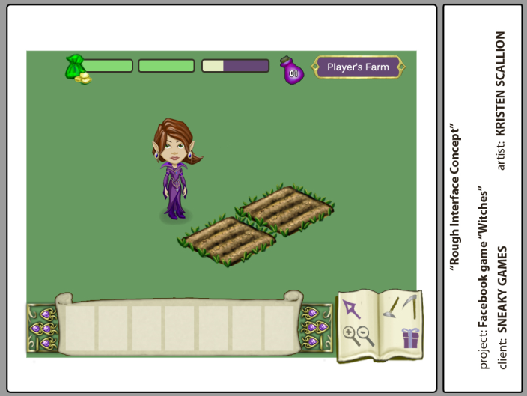

Gameflow within Fantasy Kingdoms
This is a brief overview of what a player will be doing from moment to moment. Players can do anything in pretty much any order they wish, given they have the resources or are at the appropriate level. More detail on each can be found in the corresponding section below. Effort has been made to provide hyperlinks where applicable.

Buy in-game Gold (see Premium Experience for more detail)
GOLD – is like cash, paid for in cash by the players. This is used for a Premium Experience, defined below.

Earn Mana (see Mana for more detail)
MANA – is like in-game money earned for playing well. It is used in exchange for just about everything!

Enchant Land (see Enchant for more detail)
ENCHANTing land – is like plowing. This costs the player Mana.

Purchase Spells (see Spells for more detail)
Purchase these to cast them onto enchanted land.

Cast Spells on Enchanted Land (see Cast for more detail)
CAST spell – is like planting. A player takes their Mana and exchanges it for a spell. This spell is cast upon an enchanted piece of land and it generates Reagents when it is fully cast. Casting a spell to yield Reagents or any other item takes time, from hours to days.

Plant Trees and Tree-Like Items (see Trees for more detail)
Trees generate recurring Reagents. Their Reagents stay ready as long as you need. Once the Reagents are Collected, they begin growing new ones.

Grow Reagents (see Reagents for more detail)
An early look at a wizened tree
REAGENTS (ex: iron, Mana, wood, unicorn horns, eternal flames, eye of newt, etc.) are ready to Collect when the SPELL is finally prepared.

Collect Reagents (see Collect for more detail)
COLLECTing REAGENTS is like Collecting plants. Players Collect the REAGENTS and they are placed into STORAGE. Items in STORAGE can be sold for MANA.
REAGENTS can also be combined to form special CRYSTALS – this is our form of crafting.

Forge Crystals from Reagents (see Crystals for more detail)
CRYSTALS can be created by following special recipes on unlocked scrolls.
CRYSTALS can be sold for MANA or combined (depending on the scroll that has the recipe) to make POWER ITEMS – this is definitely crafting! CRYSTALS can also be used to increase the output of special items (ex: a blue crystal power orb will produce double power for a set time)

Build and Enchant Power Items (see Power Items for more detail)
POWER ITEMS can provide all manner of benefits to the player (ex: the blue crystal power orb increases speed or growth and overall quantity of nearby growing REAGENTS).
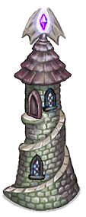
These are created by combining crystals in a sequence from a special scroll, which can be either purchased or as a prize from a friend, or a combination of other methods.

Purchase Castles and Castle Pieces (see Castles for more detail)
CASTLE PIECES can be purchased by Mana and additionally enchanted with Crystals to make them match aesthetically.
Castles are made by purchasing each piece separately, from a Wizard’s Tower to a series of walls and a moat with a drawbridge. Each piece comes from a ‘set’ that matches stylistically, but players can mix and match in any way they please. Castles match all the major witch / warlock alliance types, for instance Fire / Ice / Earth, etc. Over time, new items are made available for players.
A Wizard’s Tower focusing purple crystal power

Premium Experience – Buy in-game Gold
For players that wish to experience the full capability of the game, which enables much faster advancement and a slew of new items, etc., they can pay for that experience. The below are examples of the Premium Experience.

Accelerated Advancement
Players can possess limited use items such as: hearthstones that double your experience for an hour, or purchase spells that add efficacy of whatever sort they are assigned to their entire army. +1 Defense to all units, for example.

Micro-Transactions
Players convert their cash into in-game currency (gold). Gold is used to purchase items such as the following, within the game. These purchases are created and reserved specifically for paying customers:
- Additional storage space for inventory items. This encourages players to earn/keep more items to improve their gameplay experience. Regular gameplay can expand inventory a certain amount, but to get really large inventory, you have to pay gold.
- Membership subscription. Allows players to get a certain number of extra features, gold, etc. for each month they pay for it. There are also special Members’ Only items that are included and also special items and spells to be found only by members.
- Special Kingdom customizations. Includes special or unique items used to upgrade the physical look and feel of your kingdom and / or castle. These range from small flowers to complete castle towers. They come in a variety of colors, shapes, sizes, etc. More are added as the demand comes in from the players. These also include special items for holidays.
- Unlock features. Many of the key features are unlocked over time so players do not get overwhelmed when they begin. This helps the players become accustomed to the game before we require them to be experts at everything. Players can buy the option to open up levels by purchasing experience or by speeding up Reagent gathering. These will allow the player to “level up” faster than expected.
- Future goal: Additional Stamina and Energy points. At any time, the player can replenish their main gameplay resources.
- Future goal: Access to special events. Any developer online experiences, special member’s only parties (online), newsletters, etc. are all possibilities. This one’s going to expand over time as the community grows.
- Future Goal: Virtual item packs. These include: X common and 1 rare item. The rare item is worth more than the commons, because they may make up a set of armor or have special abilities. Sometimes the rare is a unique item, worth far more than the others as it has multiple abilities so it can use one less slot of inventory.
- Future goal: Add a new Avatar to the account. Players love leveling up and defeating evil. But then they sometimes want to see what it would be like to have a new play experience where they role-play someone of a different alignment or sex, or class, etc. So they want to start a new character. We’ll let them!
- Future goal: Avatar customizations. Includes items used to upgrade the physical look and feel of your avatar. More are added as the demand comes in from the players.
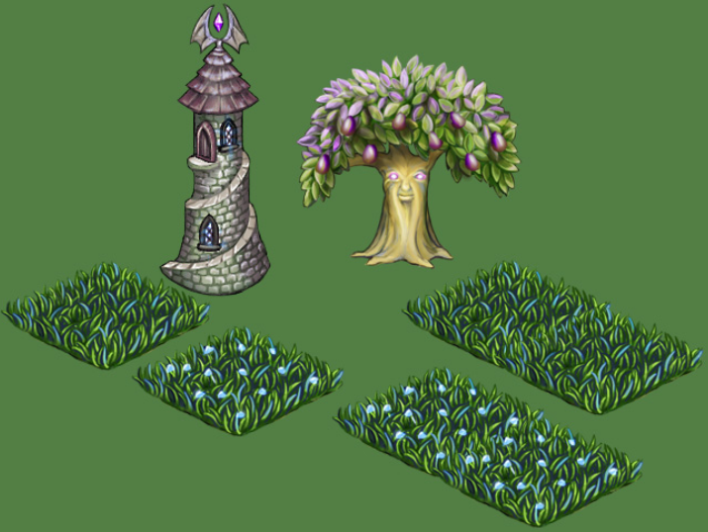

Fantasy Kingdoms Design Detail

Leveling / Experience

Experience Points
These are given whenever the player does an activity that the game developers want to encourage. This accrues until you have reached a set target, whereupon a ‘level’ is gained, and the player’s next level target is set.

Leveling up Avatar (through Kingdom-building activity)
Accumulating Avatar experience points through gameplay (in any way) can raise the level of your Avatar by reaching an experience point target. Sample Avatar leveling targets are below:
Exp. Points Level
0 1
1000 2
2000 3
5000 4
13000 5
26000 6
48000 7
100000 8
175000 9
500000 10

Avatar Creation and Editing

Account Creation
When you first log into Fantasy Kingdoms, the friendly Coven Leader will guide you easily through the setup process, coaching the player all the way, in a positive manner. Players may name their Avatar and select their gender. On the next screen players are presented with the Avatar Editor, where they can change how they want your avatar to appear on screen to themselves and other players.
Simple differences between costumes and faces make a big impact

Changing your appearance
You can change your look at any point by clicking on your Avatar and selecting 'Change Appearance' from the popup menu. This will launch the Avatar Editor.
At launch, we will have two choices, witch or warlock, and a few hairstyles and clothing options for each. We will add more over time.
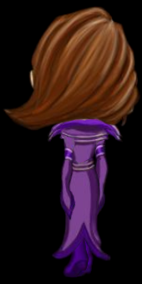
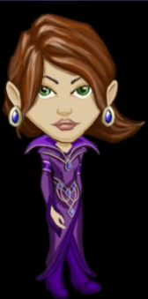

Four views of each Character are supported

Changing the name and sex of your Avatar
Click on the Account tab at the top of your Kingdom screen (it is the last tab on the far right). This will take you to another screen where you can key in your new name. Once you have changed your name it will automatically update all your Neighbors and Buddies listings to reflect your new name. You also have the option here to change the sex of your Avatar.

Game Basics: Main Things to do
The following is a short description of the initial user experience as a player first plays the game
Simple hint popups appear in-game describing exactly what the player needs to do in all of these situations. They will not be described here in order to preserve the flow of the story.
Player selects ADD APPLICATION to Facebook. The game loads, asking the player to create an avatar and customize it.
Then the player can NAME THEIR KINGDOM by clicking on the bar on the top of the Kingdom screen (to the right of the Experience Points bar). When they hover over it they will see a message appear that says "Click to edit Kingdom name" when they are finished, they just hit ‘enter’ or click anywhere else on screen to finish.
Then they need to learn how to move the camera around. They click on the green diamond-shaped logo or you can pan by clicking on a specific spot on your Kingdom and dragging your Kingdom around with your mouse.
There are already a few tiles that have been ENCHANTED in the middle of the screen, there is already MANA in their account, and a few SPELLS have been cast that need to have their REAGENTS COLLECTED.
The player can COLLECT the prepared REAGENTS, leaving behind BEWITCHED land. The player can ENCHANT that same land to prepare it for a SPELL. The player is instructed to go to their SPELL BOOK and select an available spell. When the player CASTS that SPELL on the ENCHANTED ground, the SPELL begins to take effect. It is at this point where the player reaches level 2 and also achieves their first ACHIEVEMENT AMULET to possibly post on their Facebook Wall.
The player can now try a new spell, but must purchase it with MANA. They can also take the REAGENTS to the MARKET and exchange them for MANA to further purchase more SPELLS.
Time to Make some MANA!

Make Mana (money) quickly
Short version: ENCHANT some land in neat rows, buy and CAST some spells on the Enchanted land. Then COLLECT the developed REAGENTS.
When your Reagents are ready to COLLECT, make sure you Hire someone to COLLECT them for you so that you make more Mana if you are at the right level. If you have not unlocked that ability, you must COLLECT each set of Reagents separately. For the first few days, re-invest all the Mana you make into purchasing new spells to CAST that will grow Reagents. “Moonbeams” are a good starter spell since they take a single day to grow. You'll then find you have made a decent enough profit to at least buy a couple of wrought iron fences for your Familiars, if you have been Gifted with any. Always re-ENCHANT your bewitched land (Reagents have been removed or if the Reagents went bad) before spending Mana so that you have a constant source of Mana income.
The goal is to come back to COLLECT, sell what you have Collected, and with the profits, cast more spells to create more Reagents. Repeat until you have earned enough Mana to build a Kingdom you are proud of, one or more unlocked pieces of kit at a time. Details are below.

Earn Fantasy Kingdoms Mana
Mana can be earned by selling your Reagents, crystals, or any other item you own, or by doing side-quests in someone else's Kingdom. You can earn Mana by selling the Gifts your friends send you and you can also purchase Mana with micro-transactions.

Visit the Market
When you arrive in the Market click on the walk button and then click your cursor on an area you would like to walk to. Your avatar will move there.
You can sell your Reagents to earn Mana, and then purchase items with Mana.
In future revisions, you can hire others to help you with your Kingdom if people ask you to help them with their Kingdoms. This is a good way to make Mana and earn experience. See MARKET

Spend Fantasy Kingdoms Mana in the Market
Mana also lets you purchase spells that create other items that “grow” into the Enchanted land and many times produce Reagents. These can be trees, power focusers, mines, Familiars, bullfrog swamps, magic forest, buildings and more for your Kingdom. See MARKET

Visit other people's Kingdoms
You can click on people in your Neighbors List to visit their Kingdoms, or you can click on the list of people right at the bottom of your screen when you are in your Kingdom (it has a horizontal list of people playing with their Avatars underneath). See NEIGHBORS

Participate in the Daily Lottery
This message appears on players’ screens each day. This is an amount of Mana that you earn for each day that you log into Fantasy Kingdoms. The amount is randomly chosen based upon how long the player has been away from the game.

Buying Gold (see Premium Experience for more information)
Gold is bought by players using real world money. It can be exchanged for Mana or any of a number of ways to expand your player experience. Many unique items can only be purchased with Gold. This separates the payers from the players.

Earning Mana
Mana is the ‘coin’ of the realm, if you will pardon the pun. Everything that is done in the game in one form or another relates to Mana. You earn Mana in your bank to spend on new items, etc. Details on how to earn Mana are covered in each section below.

Building your Castle!
Players can build their own castle out of any pieces they can afford and that they like. Players can choose from any type of castle piece, from walls to moats, interior storage, to Wizard’s Towers. These pieces interlock so that players can create infinite possibilities. Over time, new castle pieces will be made available so that players always have new ways to customize their castle.
Special castle pieces create Reagents or affect Reagents near them, very much like Power Items.
In future builds, we plan to have the interior of player castles function like a doll house where players can buy and move furniture, etc. around to their heart’s content.

Castle Pieces
Many of these pieces (TBD) can be customized with a crystal. They have ZERO affect on gameplay. This type of gameplay may be added in the future.
Name Description
Traditional Castle
Traditional Towers (4) Matches its corresponding castle’s look
Traditional Walls/Add-Ons Must be able to assemble a full square, at least
Medieval Castle
Medieval Towers (4) Matches its corresponding castle’s look
Medieval Walls/Add-Ons Must be able to assemble a full square, at least
Gothic Castle
Gothic Towers (4) Matches its corresponding castle’s look
Gothic Walls/Add-Ons Must be able to assemble a full square, at least
Fantasy Castle
Fantasy Towers (4) Matches its corresponding castle’s look
Fantasy Walls/Add-Ons Must be able to assemble a full square, at least
Spiraling Castle
Spiraling Towers (4) Matches its corresponding castle’s look
Spiraling Walls/Add-Ons Must be able to assemble a full square, at least
Modern Castle
Modern Towers (4) Matches its corresponding castle’s look
Modern Walls/Add-Ons Must be able to assemble a full square, at least
Crazy Castle
Crazy Towers (4) Matches its corresponding castle’s look
Crazy Walls/Add-Ons Must be able to assemble a full square, at least
Earthly Castle
Earthly Towers (4) Matches its corresponding castle’s look
Earthly Walls/Add-Ons Must be able to assemble a full square, at least
Air Castle
Air Towers (4) Matches its corresponding castle’s look
Air Walls/Add-Ons Must be able to assemble a full square, at least
Water/Ice Castle
Water Towers (4) Matches its corresponding castle’s look
Water Walls/Add-Ons Must be able to assemble a full square, at least
Fire Castle
Fire Towers (4) Matches its corresponding castle’s look
Fire Walls/Add-Ons Must be able to assemble a full square, at least
Shadow Castle
Shadow Towers (4) Matches its corresponding castle’s look
Shadow Walls/Add-Ons Must be able to assemble a full square, at least
Halo Castle
Halo Towers (4) Matches its corresponding castle’s look
Halo Walls/Add-Ons Must be able to assemble a full square, at least
Harmony Castle
Harmony Towers (4) Matches its corresponding castle’s look
Harmony Walls/Add-Ons Must be able to assemble a full square, at least

Enchanting Land
To have the ability to cast spells onto a piece of land, you need to Enchant the ground using the Cauldron (see Cauldron icon). This enchantment costs Mana. Players are rewarded for Enchanting their land with experience. The amount of experience received will vary depending on the spell. Once the field is Enchanted, you can go to the Market and purchase spells for Reagents you want to Collect, then with the spell bag selected, click on the tilled fields to cast. Note: You are only charged for spells when you actually click on the plot to cast them.
Most spells require one land tile to cast, but advanced spells require more enchanted land in order to cast.

Buying and Casting Spells
Spells must be purchased and then cast upon enchanted land. These spells take time to mature, depending on the spell, and when they do, the player can Collect the Reagents that come from them.
Certain spells are unlocked either through having enough Mana saved up, or by reaching a certain level. Still further spells are unlocked after a game event occurs, such as reaching a certain proficiency with another spell. For instance, if you cast the “moonbeam” spell enough times until it is level 2, the new spell for moonbeam will generate additional Reagents and experience.
Still other spells are considered recipes to create crystals. Combining Reagents in a particular order will generate special crystals that can be used to generate new Power Items.
It is important to note that if you do not have the spell for that combination of Reagents, it is not possible to forge that new item or cast that new spell.

Reagents
These are the basic building block of all magic items. They can be sold for Mana, or they can be combined through the use of unlocked spells (like recipes) in your personal spell book.
There is a wide variety of Spells that create unique Reagents. Each has a set cost, a duration it takes to cast, and amount of Reagent it will generate when Collected. Players take these Reagents and either combine them with others using sorcery (like a spellbook with spells that get unlocked over time), or save them in their inventory. Selling Reagents at the Market is a good way to make some Mana!

Collecting Reagents
Simply click on the item or completed spell that contains the Reagents. Every time you Collect Reagents you are given the option to sell your Reagents right there from your Kingdom, or to Collect them and place them in storage. If you sell the Reagents from your Kingdom, you earn less Mana than if you place them in storage and go to sell them at the Market. Items in storage can also be used to create crystals, etc., so selling them isn’t always the best idea…
Once a spell or item is ready to be Collected, use the Collect Tool (Bottle icon) and click on the field, statue, tree, or other location / object / Familiar to be Collected from. This bottle indicates locations for the avatar to Collect the Reagents.

List of Reagents
SPELL/REAGENT APPEARANCE
Eye of Newt NEEDS DESCRIPTION
Toadstool NEEDS DESCRIPTION
Ginger root NEEDS DESCRIPTION
Lizard tails NEEDS DESCRIPTION
Broomsticks NEEDS DESCRIPTION
Pixie Dust Dandelion-style flower with golden dust
Mandrake NEEDS DESCRIPTION
Ground Ivy Ivy close to the ground, with tendrils
Belladonna A golden bell with a “D” on it
Hemlock Flower with a lock on it
Dandelion Lion Faced Flower
Snake Grass Snakes with tails planted in ground
Fresia Frozen pastel blue colored
Iris Eye on a stem (multi colored)
Bluebonnet Different shade of blue bonnets grown in bunches
Butter cups Pastel yellow petal cup on a stem
Blue Bells Line of blue Chiming bells
Indian Paintbrushes Various shades of paint on black brushes
Marigolds Gold Reagents in branches
Magic Beans NEEDS DESCRIPTION
Cat Tails different colored cat tails, grows in bunches
Four Leaf Clovers Large four leaf clovers

Duration of growth until time to Collect
This varies among the different types of Reagents. The time it takes for each Reagent is shown in the Market next to the spell name.

Bewitched Reagents
Reagents can be Bewitched (i.e. not Collected in time) once a player reaches level 5. The goal is to allow players to get the hang of the game for long enough with a ‘safety net’ so they understand the game basics as well as get a pretty good Kingdom started.

Bewitching Description
If a Reagent is ready to be Collected and is not Collected right away it may become Bewitched. Note: a Fantasy Kingdoms day is approximately 20 hours. At this point in time, Reagents on trees do not become Bewitched.

Reagent Bewitching Time
The duration of time that it takes to Bewitch a Reagent is 50% of the time it takes for the spell to be fully cast. For example, if it takes 8 hours to fully cast a spell, it will take an additional 4 hours before that spell becomes Bewitched.

Re-casting Spells after being Bewitched
One MASSIVE change between Fantasy Kingdoms and other ‘farm-like’ games is that when a Reagent is Bewitched, it can immediately be re-cast with a special spell that becomes unlocked at the same time as Bewitching is made a reality. It is essentially a ‘do-over’ of the spell that only costs a slight amount of Mana. The GOAL of this do-over is to allow players to always make forward progress, without affecting their gameplay in a negative manner. Specifics below:
Before level 5 (TBD what it really is) no crops get Bewitched. This is to encourage players to keep coming back and not get discouraged. At the time that Bewitching becomes a reality, we clearly and thoroughly instruct the players as to what Bewitching is and how to work with it.
An Unbewitching spell” (name will be super cool, but is TBD) becomes available at the same time as Bewitching becomes a reality. This spell is automatically put in your spellbook. It is a low-Mana cost spell, and it Unbewitches all the Bewitched Reagents at the same time with one cast for one cost. It’s MAGIC! It also resets your Reagents to 100% growth, so you can Collect them immediately, but their Reagent yield will be lowered by a certain amount randomly between 5-50%, depending on your mastery of the spell, which is the real cost of the spell.
It is possible that we will find that this adjustment to CORE farming-style-gameplay amazing, or it may stink. We need to try it out and balance it carefully.

Crystals
Crystals can be gifted to other players, received from other players, or they can be crafted by using Reagents through a spell. These Crystals go into the player’s inventory until they choose to use them.
Crystals are used to: create Power Items, enchant Power Items for particular uses, or enchanting parts of your castle.
New uses for Crystals are generated over time. They can also be sold for Mana.

Power Items
Power Items are very special items, indeed. They can possess many different traits depending on what they are. For instance, a Mana Generator can produce a certain amount Mana every set amount of time. These need to be rejuvenated with a spell after they run out of magic.
Other Power Items can help nearby items generate additional Reagents or they can make creatures more likely to visit them. For instance, a Magic Rainbow will attract Leprechauns and they will leave behind Mana if they are NOT disturbed until their grow time is completed
Special Power Items are very powerful. They are also larger or in different shapes than most items. A Stonehenge circle will be much larger than a basic tile, and it will generate crystals over a long period of time. Once the crystals have been Collected, a new spell must be cast upon it to make it possible for it to produce again. This method is very similar to having a ‘tree,’ except that you have to re-enchant these items.
Any time a player wishes to remove one of these items, they can be placed in storage or sold. If they are placed in storage, they are essentially new when brought back out, and need to be enchanted again to begin generating crystals.
Other items that work in this manner: Unicorn Circles, Magic Frog Ponds, Gargoyle Nests, etc.

Power Items that Impact Gameplay or Generate Reagents
Item Name Effect on Gameplay Description
Emerald Power Focus + yield of nearby Reagents Pedestal w/Green Crystal
Amethyst Power Focus + CLARITY* Pedestal w/Purple Crystal
Ruby Power Focus + LUCK** Pedestal w/Red Crystal
Diamond Power Focus Prevents bewitching of nearby Reagents Pedestal w/Diamond Crystal
Unicorn Circle Produces Unicorn Horns Cool ass fantasy circle
Fairy Circle Produces Pixie Dust Cool ass fantasy circle
Magic Swamp Produces Will-o-the Wisps NEEDS DESCRIPTION
Magic Ore Can be used in Crafting Mine Entrance
Golden Geese Pond NEEDS DESCRIPTION Generates Golden Eggs
Wizard’s Tower NEEDS DESCRIPTION Kristen already did it

* Clarity is the ‘mythological’ effect of Amethyst. We need to find a use for it.
** Luck is the ‘mythological’ effect of Rubies. This would be used to generate additional LUCKY rolls when used nearby something. For example, one could pick a “perfect” flower at a higher rate of incidence, or anything that is controlled by a dice roll. The goal is for the player to feel as if they have more LUCK.

Trees / Forests
Trees function in one manner. They are planted and they produce Reagents. Once those Reagents have been Collected, the tree goes back to generating the same Reagent. Their Reagents never spoil and they also never grow more than one single batch.
Forests are large stands of trees that when taken together have a new attribute. For instance, if you have one haunted tree, it can generate magic wood, but if you have 9 of them connected together, they generated more Reagents together than they would have separately. Players just have to wait until they all complete their enchantment of the Reagent before they get its benefit.

Trees that Generate Reagents
Name/Reagent Description
Poison Apple Grows one blood dripping apple at a time
Ghost Slime Haunted Tree
Weeping Willow Crying Willow Tree with branch arms
Dogwood tree Dog looking leaves, (generates ‘barking’ tree bark)
Cats’ Whiskers Bush with cute whiskers
Enchanted Wood Magic Tree
Dark Wood Scary, scary tree
Phoenix Feathers Red tree with fiery leaves when ready to Collect

Enchanting Items
Many items, from Trees to Power Items can be enchanted so they generate additional Reagents. The spells to achieve this are available in the player’s spell book. Many of these enchantments are locked so that only higher level players have access to them.

The Market
When you click on the Market Icon, a screen pops up asking you what you would like to do in the Market. The market is where players exchange items, etc. Buy and sell the following items, from the corresponding tabs in the menu:
- Spells, with Subtabs for All, Potions, Scrolls, and anything else we can think of to cast a spell
- Trees
- Familiars
- Castles, with Subtabs for ALL, Castles, Walls, Towers, Storage, Other
- Decorations, with Subtabs for Flags, Suits of Armor, Ivy, Topiaries, Rocks, Water, Other
- Upgrade Kingdom, with Subtabs for All, Expand, Landscape (like winter or fall, etc.)
- Power Items

Locked items in Market
Anything that is marked as “Locked” is either to be unlocked at a specific player experience level or will be coming online in a future release.

Decorations
Stream (straight) Non-magical, just decoration
Stream (left curve) Non-magical, just decoration
Stream (right curve) Non-magical, just decoration
Waterfall Non-magical, just decoration
Small Pond Non-magical, just decoration
Medium Pond Non-magical, just decoration
Large Pond Non-magical, just decoration
Dirt Path (straight) Non-magical, just decoration
Dirt Path (left curve) Non-magical, just decoration
Dirt Path (right curve) Non-magical, just decoration
Stone Path (straight) Non-magical, just decoration
Stone Path (left curve) Non-magical, just decoration
Stone Path (right curve) Non-magical, just decoration
Light Post 1 Non-magical, just decoration
Light Post 2 Non-magical, just decoration
Light Post 3 Non-magical, just decoration
Wooden Fence Non-magical, just decoration
Stone Fence Non-magical, just decoration
Metal Fence Non-magical, just decoration
Wooden Gate Non-magical, just decoration
Stone Gate Non-magical, just decoration
Metal Gate Non-magical, just decoration
Vine 1 Non-magical, just decoration
Vine 2 Non-magical, just decoration
Vine 3 Non-magical, just decoration

Selling items from my Kingdom
To be able to start selling items on your Kingdom e.g. Familiars, trees etc... you need to have unlocked/earned the required Trophy.

Misc Art Needs for Market
Name Description
Mana Mana is the coin of the realm so it should seem to have value
Gold This is what people BUY – so it should look like it is CASH, essentially
Typestyle Some typestyle that we can use all over the place
Cauldron Three sizes of black magic cauldrons. Maybe has animating fire?
Fantasy Kingdoms Logo Cool as Hell Logo that gives you the feeling of “Building Your Kingdom”

Alchemy: Crafting / Combining
Reagents and other items can be “combined” through Alchemy. Alchemy can only be practiced when a player has advanced far enough to unlock / purchase a Cauldron. We can also have different sized Cauldrons that will allow for more advanced Alchemy.

Potions
Potions are one time use items that are kept in the player’s inventory until used.
Item Name Reagents Needed Effect
Dryad Spirit Speeds up production of tree Reagents
Fairy Ointment Lengthens duration of items of power
Enchant Spell Enhances the yield of X Reagents

(I moved this to another section on gifting)Crystals
Crystals are one time use items that are kept in the player’s inventory until used. Fundamentally, each crystal should represent a certain birthrite, although these are not known at launch.
Item Name Reagents Needed Effect
Earth
Air
Fire
Ice
Shadow (bad/evil)
Halo (good)
Harmony (good/evil balance)

Amulets
Amulets are one time use items that are kept in the player’s inventory until used.
Item Name Reagents Needed Effect
Insert Text

Wards
Wards are one time use items that are kept in the player’s inventory until used.
Item Name Reagents Needed Effect
Insert Text

GUI
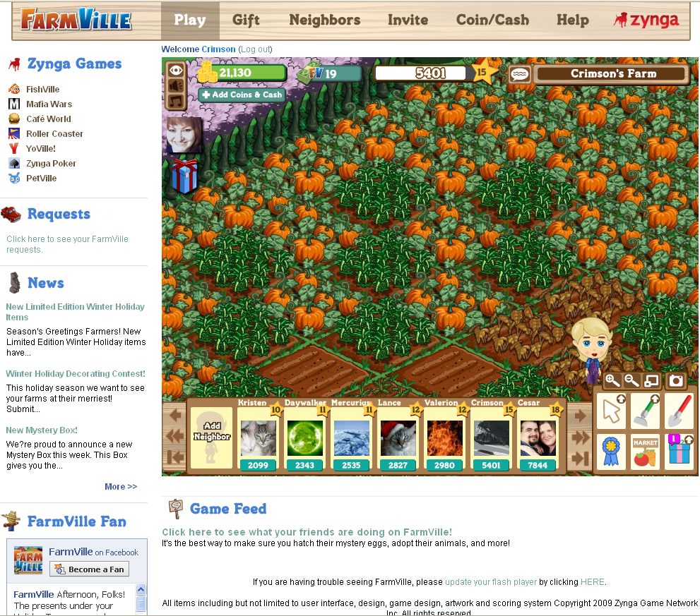
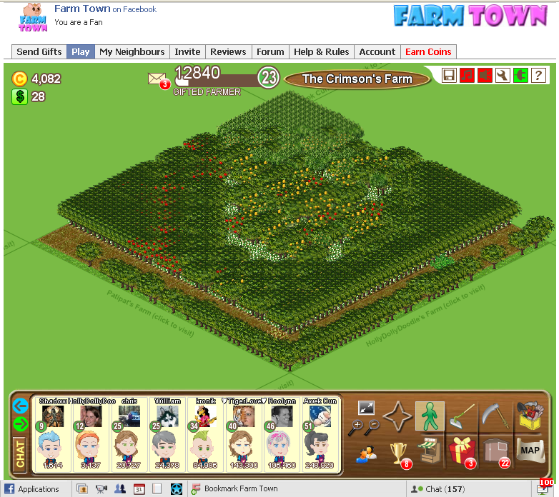
There are two parts to the Graphical User Interface, the border (outside the game) and game GUIs. Here are two example farming type games that have similar gameplay GUIs to ours.

Border GUI – The Game View’s “Frame”
The GUI that surrounds the main game interface. This border allows for the player to interact with the game and community in ways that do not fit within the regular confines of the game. It also has the company logo, the game logo, and listings of anything else we want to add, such as our Twitter feed, becoming a “FAN” of the game on Facebook, how to play outside of Facebook and the like.

Play
This changes the game view back to gameplay.

Gift
This takes you to the central gifting interface that happens the first time you boot up the game each day.

Neighbors
From this page, you can invite your Friends to become Neighbors.

Invite
From this page, you can invite friends that are not playing the game to get an account and play!

Reviews
I’m not sure that these will be needed from the beginning, but we need to be ready to add these. It could really help!

Forum
Insert Text

Help
All the tips and tricks you need are here.

Account
Insert Text

Mana / Cash
From this screen you can buy Kingdoms’ Cash OR you can buy Kingdom’s Mana.

Company Logo
Clicking this takes you to Sneaky Games’ website. Which will need an overhaul before we add this link.

Game GUI – From Within The Game View Frame
The GUI within the game interface allows players to directly interact with the game and your neighbors, gifts and achievements. It is the primary way to interface with the game.
There are a few tools on screen for the player to manipulate so they can do what they need to do.

Wand
A context sensitive mouse cursor. When it is depressed, it provides any vehicle – style options we may desire to have / add.

Cauldron
Used to ‘enchant’ land. There are three sizes of cauldron to be purchased when unlocked. These allow the player to enchant more than one tile at a time. See ENCHANT

Scythe
Using this tool allows players to clear the land after it has been bewitched. See BEWITCHED

Charms
Achievement screen. See CHARMS

Market
Takes players to the market. See MARKET

Gifts
Allows players to give gifts. See GIFTS

Neighbor bar
Shows who your neighbors are. See NEIGHBORS

Zoom buttons
In and out

Camera
Takes a screenshot and posts it to your account

Full screen
Toggles full screen.

Options – General Game Options
These are the buttons that are on screen during main gameplay that affect the game.

Music
Toggles music in the game. Click on the musical symbol and the button will turn green when on and red when off. You will no longer hear the music while playing the game.

Sounds Toggle
Toggles sound effects.

Preferences
This is the link to the Preferences Menu. The following options are available:
- Show Trees / Show Flowers / Show Buildings - If these options are unchecked, all trees, flowers and buildings will be hidden from your view. You will be able to Enchant and cast spells on your own Kingdom with these items out of the way and you can use this option on other Kingdoms when Collecting.
- Freeze Familiars - this option allows you to halt the movement of your Familiars so that you can move fences without your Familiars escaping.
- Remove Space Between Tiles - this option will allow you to place plots side-by-side when Enchanting instead of having a space in between. Smooth Graphics - this option may produce higher quality graphics, but depending on the computer, may create slow-downs.
- Follow Avatar While Walking - this option, when unchecked, stops the screen from jumping and following the Avatar around when you are Enchanting or Collecting.

Help
This is the Help feature. It repeats the help that you received when you first set up your Kingdom by indicating where the Enchant tool and the Collecting tool are, as well as the Market access. You can click on this button at any time to repeat these instructions.

Charms (Trophies)
These are achieved when you have added Neighbors to your Kingdom:
- Popular Neighbor - 5 Friends Needed
- Influential Neighbor - 8 Friends Needed
- Acclaimed Neighbor - 10 Friends Needed
- Proper Neighbor - 15 Friends Needed

When you visit your friends' Kingdoms and help them clean up, etc., these are tracked as Visits. Visit your friends enough times each day to reach the amount needed for the next trophy.
- Apprentice Traveler - Make 25 Visits
- Addict Traveler - Make 100 Visits
- Compulsive Traveler - Make 300 Visits
- Obsessive Traveler - Make 1000 Visits
- Tourist Traveler - Make 5000 Visits

There are many additional Charms for special situations we want to encourage players to experience.
- “SPENDING 500” – earned by spending 500 Mana in the Market

Neighbors
Your Neighbors are friends whose Kingdoms are close to yours.

Adding Friends as Neighbors
Go to the 'My Neighbors' tab. If your friends have a Kingdom in Fantasy Kingdoms, click on 'Add as a Neighbor'. If your friends do not own a Kingdom yet, select them from the list, and invite them over.

Visiting Neighbors’ Kingdoms
You can visit your other Neighbors (Facebook Friends with the Fantasy Kingdoms app) by clicking on your Neighbors Tab at the top of your Kingdom screen. This will take you to a list of all your Neighbors. If you click on their Kingdom it will take you there directly. You have no way of knowing whether these Neighbors are online or not - a good suggestion is to put those Neighbors on your Coven List when you see them. When you click on your Coven List in future and scroll down a green light will be activated to the right of their name if they are online at the same time as you. You can also get to their Kingdoms from there.

Difference between Neighbors and Buddies
Neighbors have to be Facebook Friends and then you can send them Gifts. When you visit Neighbors, you will have the option to help them tend their kingdom in some way. You will be able to do this once a day per Neighbor. You cannot do this with Buddies.

Limits on Neighbors
You can have an unlimited number of Neighbors. You will be able to send and receive Gifts from all of these Neighbors. To add Neighbors use the arrows to move across to an empty slot and click on that to add them. They will receive a Neighbor Request which they will have to approve. To appear on their Neighbor Bar, they will need to send you a request too.
The play experience we want to encourage is having people easily visit / help their neighbors. How we get there will be a mashup of the best practices in other games. We will leave the detail of how to handle this to the people implementing this feature when it is time to implement it.
The goal for this feature: Players can easily add neighbors to their Kingdom so that this enhances every neighbor’s play experience. Players can easily send requests to their Facebook Friends for them to become neighbors (whether they play Fantasy Kingdoms or not, but there will be CLEAR instructions as to how to just send to current players that are already your friends). This adds them to the neighbor bar so they are easily found. They are sorted by lowest experience level to highest, so that the highest level is on the right, and is easiest to click on. I also think that we’ll make changes later so that you can easily rearrange your friends with a drag and drop interface. PLAYERS should be in charge of that – not some sort algorithm.
We also wish to find a way to remove inactive neighbors. This may have to wait until later, but I didn’t want to forget it!

Buddies

Buddy List
These are people you meet in game and want to be able to connect with through the game. They may or may not be Facebook Friends or a part of their coven.

Visiting my Buddies
Click on the two person logo at the bottom right of your screen and you will get a list of all the people you have added to your Coven List. If there is a green button on the far right of their name then they are online. If you click the "walking person" symbol on the left of the green button it will allow you to visit their Kingdom.

Tending Other People’s Kingdoms
From time to time while you are in your Kingdom view, a random message will appear asking the player to interact with someone else’s Kingdom. These players may or may not be friends with the player. The idea is to show the player the other farms that other players have created. Oftentimes that is a huge way to give people something to achieve. People love showing off!

Random Events on Other Kingdoms

Cleaning up Stray Leaves with Wind Rush Spell
Wind Rush cleans out the Kingdom of broken branches and leaves.

Clear up Loose Pixie Dust with Fairy Dusting Spell
Fairy Dusting gets rid of the non-magical pixie dust.

Remove Fog / Clouds with Cloudgone Spell
Cloudgone sends the clouds that are fogging the land packing.
You cannot purchase these Spells in the Market. When you are asked to help tend another players’ Kingdom a screen will pop up telling you what needs to be done e.g. if their Kingdom needs a cleaning, it will ask if you want to do that. You will get two options - either Cast Wind Rush (if you have already bought one before) and Buy Wind Rush Spell. You click on this option and you will automatically purchase a Wind Rush Spell with 5 uses.

Other ideas for Events
- Ogres raiding your kingdom (for the boys)
- A bad witch casts a spell over the kingdom making everything look dead, so you cast a spell to make things beautiful again
- Familiars are sick from eating poison apples

Experience Points for Tending Neighbors’ Kingdoms
Exp points go from 6 to 1 when tending a Neighbor’s Kingdom, because you earn 6 exp points for every Neighbor whose Kingdom you tend within a 24-hour period up to a limit of 50. After that you earn 1 exp point until the clock resets.
Andrea comments: Makes more sense for me to have this (the number 50 above) be a number that is divisible by ‘6’ so it’s a set number of times you get the “max return” but it can be sorted out in game play balancing.
Billy: I’m good with whatever we decide when it’s time to implement this.

Flowers
Flowers are a pain in the ass in other games. They will be FUN in Fantasy Kingdoms.
In order to allow players to visually customize their Kingdom, they can purchase non-magical multicolored flowers.
FUTURE FEATURE: Eventually these flowers can be cross bred by combining two seeds from different flowers. This gives the players the ability to grow flowers and trade the seeds for others to combine and breed new combinations.

Basic Flowers
Name Description Color
Base Flower 1 One Color Flower Red
Base Flower 2 One Color Flower Orange
Base Flower 3 One Color Flower Yellow
Base Flower 4 One Color Flower Green
Base Flower 5 One Color Flower Blue
Base Flower 6 One Color Flower Indigo
Base Flower 7 One Color Flower Violet
Base Flower 8 One Color Flower White
Base Flower 9 One Color Flower Green
Base Flower 10 One Color Flower Black

Combinations of Flowers
Without an exhaustive listing of possible combinations and additional flower colors, let’s just say that the base flowers can be combined one time. For instance if a player combines Black and Red flower seeds, they will result in a Black and Red flower. Over time, we will add new flower combinations as the players wish for them.

Flower Care / Growth
There has to be a good way to make flowers work. Flowers grow on their own, and players can stop their growth at any time. All this watering stuff is just TOO MUCH. If players complain, we’ll ask them for an answer and try something else.
The flowers take about 3 days till they are fully grown and are in full bloom.

Earning Experience Points for Growing Flowers
Each flower that reaches maturity (for the first time) earns the player 1 experience point.

“Hiding” Flowers
Uncheck “Show Flowers” (click on the correct option in your Kingdom menu) and refresh your Kingdom once you have done so.

Collecting Seeds
Once a flower has reached full maturity, you can Collect its seed. This destroys the flower.

Selling Flowers
The flowers can be sold. If you click on them (whether just planted or in full bloom) the pop-up menu will give you the option to sell.

“Freezing” flowers
All of a player’s flowers can be frozen at the same time or they can be frozen individually. One further note is that once a flower has reached full maturity, the player can change each flower to any level of maturity they wish. Just imagine what players could do with that level of coolness.

Stages of Growth / Movement of Flowers
Moving a flower has no effect on its stage of growth.

Familiars

Adding Familiars to my Kingdom
You can purchase Familiars in the Market. Some Familiars are made available as you progress in the game. You can also ask your friends to send you Familiars as Gifts (using the Send Gifts page).
Players can only have one magical familiar at a time. The rest are visitors that stay like friends, until the player casts ‘Make Familiar’ on them again. As the player unlocks, is gifted, or finds new familiars, the player can choose to keep the other as a future familiar. This would mean that the prior familiar one can stay like a friend or the player can sell it.
Players that keep their prior familiars around enjoy the benefit of leveling their unique attributes by choosing them as your familiar for certain actions.

Playing with your Familiars
Clicking your familiar makes them stop and do something. For instance, a black cat will sit and lick its paw.

Selling Familiars
Click on the Familiar, and select 'Sell' from the popup menu. Notice that the sell price is much less than what you paid on the Market, if you did.

Function of Familiars

Resale
You can sell the Familiars by clicking on them and choosing the option to sell. This is only worth your while if you have received them as Gifts.

Production of Reagents
Once you have a Familiar added to your Kingdom, they can cast their own spell to speed up growth of your Reagents. This spell is only available once to each familiar each day. Some familiars may have additional special powers!

Familiar Leveling Up
Each familiar has a series of statistics / attributes that make them unique. When a player uses a familiar, its abilities grow over use. They each earn experience individually. Some examples of the type of skills that familiars can have
- Add X% production to Y Reagent producing items per day, player’s choice
- Add X% speed increase (and adding time to bewitching) to Y Reagent producing items per day, player’s choice (Andrea asked: “Does this mean that if you speed up your spell, it is also going to take longer to bewitch?” Billy says: the goal here is to make the yield faster without making Bewitching faster, in fact it could lengthen or remove the Bewitching time. This may be too confusing, but I’d like to try it or something like it.)
- Add X% experience boost to Y Reagent producing items per day, player’s choice
- Add X% of total yield in Mana to Y Reagent producing items per day, player’s choice
As the familiar increases in levels, the value of X goes up slightly and / or the value of Y goes up slightly.

Fantasy Kingdoms’ Gifts

Gifts Sent to Fantasy Kingdoms Facebook Friends Only
There is a Kingdom Friends Tab in the middle between the All Friends and Facebook Friends tabs. When you have clicked on a Gift and have proceeded to send the item these options will appear. The Kingdom Friends list will show all those people who are your Facebook Friends who all have the Fantasy Kingdoms app loaded (these are your Neighbors in Fantasy Kingdoms).

Limits to Gift Sending
The current limit is around 28 (this is determined by Facebook and may change on a daily basis). You can send a Gift to the same friend twice during the space of a day (AM & PM) e.g. you can send 14 Gifts to 12 friends in the morning and then again to the same friends in the afternoon, or 28 Gifts to different friends once a day. Gift requests reset at 12am PST (you then have a full 24-hours from that period to send your daily allotment within). Bear in mind that your Neighbor requests are part of the daily limit that you have for sending Gifts e.g. if you send three Neighbor requests you will only be able to send 25 Gifts for the day.

Ignoring Gift Invites from Specific Friends
These instructions are similar to other games’ instructions. Our directions will differ as we implement this feature.
Below the Accept Gift button in your requests box is a small link that reads "Ignore All Invites From This Friend."
To check to see if you accidentally Ignored someone, hover your pointer over the setting link in Facebook, wait for the drop down menu to pop up and choose Privacy Settings. When the page refreshes choose the Applications option. Next choose the Settings tab. Scroll all the way to the bottom of the page and you will see a link that says "Ignored Application Inviters." Is the person’s name listed there? If so, there should be a link to remove the block. Remember to save your changes.

Gifts

Potions
Name Description/Effect
Love Potion Gives you and your neighbors some benefit i.e. “Spreading the love”
Potion x TBD
Potion x TBD
Potion x TBD
Potion x TBD
Potion x TBD

Spell x TBD
Spell x TBD
Spell x TBD
Spell x TBD
Spell x TBD
Spell x TBD

Familiar x TBD
Familiar x TBD
Familiar x TBD
Familiar x TBD
Familiar x TBD
Familiar x TBD

Crystal x TBD
Crystal x TBD
Crystal x TBD
Crystal x TBD

Flower Seed x TBD
Flower Seed x TBD
Flower Seed x TBD
Flower Seed x TBD

Blocking Users

Reporting users for inappropriate behavior
Click on the user, and select 'Ignore User' in the popup menu. This will keep the user from contacting you again. If a user is reported by enough people, the user will be banned for all eternity and thereafter.

Unblocking Neighbors/Buddies
Click on the Accounts tab at the top of your Kingdom screen. Click on Blocked Users next to Preferences and then unblock the user from the list that appears. Note: As soon as you have ignored someone they will be the first person on the ignored user list.

Messaging System
The envelope on the Kingdom screen is the messaging centre. When you have received a message red numbers will appear indicating the number of messages you have available. Click on the envelope and your messages will be opened. The message centre stores the last 10 messages that you have received. You can access these by clicking on the empty envelope. These will be overridden by incoming messages. If you click on the walking symbol on the bottom right of the message screen, you will be able to visit the Kingdom of the person who left you the message.

Kingdom Estate Office
Kingdom Estate Office increases the size of players’ Kingdoms. It is accessible through the Market. See MARKET
You gain access to the Real Estate Office at level 15. The first upgrade will cost you 20,000 Mana, the second 25,000, the third 30,000 (increasing in increments of 5,000 Mana) except for the final upgrade 50,000 for a 24x24. To gain access to each upgrade, you need to purchase the one before it - they have to be purchased in sequential order, you cannot skip an upgrade as all other upgrades will remain locked. You have to buy the 14x14 Kingdom upgrade first and the next upgrade (16x16) will be unlocked. The 14x14 will then disappear from the Kingdom Estate Screen. When you upgrade to the next size up the same thing will happen.

Miscellaneous Details

Rotating walls / fencing
Simply click the rotate button.

"Send as a Gift" option
When you click on special items (such as a tree, large plant, or a large power crystal), the option to Send as a Gift appears. This does not send the actual item you have clicked on. It merely redirects you to send a Gift to a Fantasy Kingdoms Facebook Friend (Neighbor). You can only do this is you have that specific item unlocked in the game. This will also count towards your 24 daily Gift limit.

Hiding trees or large items
The hide function helps players reach Reagents that may be hidden by trees or buildings. When you click on a tree (or any other item like buildings) you will receive an option to "Hide" that tree.

Appendices

Appendix: Viral Hooks
No discussion of a Facebook game would be complete without the inclusion of viral hooks. A viral hook is an overall way to explain anything that happens from within the game that can interact with anything outside of the game, including people that have signed up to play the game as well as people that are playing the game that instant. For instance, you can import your friends from Facebook. You can send Gifts from within the app, and they can receive an email in real life. You can go view your neighbors’ Kingdoms, etc. It is anything that can spread virally, if everyone can do it.
In its simplest version, some type of viral hook can be attached to each and every action the player makes, down to the button press. This is an attempt to categorize the main types of viral hooks.

Random Hooks
Some viral hooks happen randomly, at a time where the game is idle for a while. For instance, a random message from a random player of the game says that they need the player’s help. The player then goes to their Kingdom, taking full stock of that Kingdom’s layout, the things they have bought, and the level of Reagents they are enchanting.

Infrequent Hooks
Some viral hooks happen infrequently, at a time where an event occurs over and over as a behind-the-scenes dice is rolled. Once the desired frequency is set, those events are triggered and an example of a result would be the opportunity to gain more resources or have something happen that would be posted to their friends’ walls on Facebook.

Consistent Hooks
Some viral hooks happen on a consistent basis. When this particular event happens, this hook will be employed every time. An example of this is when a player “dings,” or gains a level. Each and every time that happens, a special message is created to be added on their friends’ statuses.

Combination Hooks
Finally, some viral hooks are a combination of the above. For instance, if you achieve some objective, such as a level up (a consistent hook), you may have the opportunity to choose from a prize, and the ones you do not choose get gifted to your friends (an infrequent hook).

Hooks within Fantasy Kingdoms
Descriptions of viral hook specifics are below. Remember, any of these can have sub-hooks such as ‘add a Choose One hook,’ below.
Level Up – each time the player dings, this message is sent to the player’s wall.
Achievement Completed – each time a player gets an achievement ding, this message is sent to the player’s wall.
Special Items Purchased – when the player first unlocks OR purchases a special item, that message is sent to the player’s wall. Examples additional land, certain spells, Reagents, crystals, power items, familiars, etc.
Choose One – Pick one from three options and give the others to your friends. They have to accept it in their requests area in Facebook.
Daily Lottery – Each day, a random amount of Mana is given to the player the first time they log in that day.

Appendix: Equivalent Terms to Farm Games
HOME STUDY
GIFTS GIFTS
STORAGE STORAGE
ZOOM ZOOM (should look like a Crystal Ball)
MOVE CAMERA MOVE CAMERA
WALK WALK
SEEDS COVEN (SPELLS / SEEDS for sale)
PLOW ENCHANT
COLLECT COLLECT
TOOLS TOOLS
TROPHIES CHARMS
STORE SPELL BOOK
MAP MAP (Includes: Marketplace, The Bank, Fairy Dust Bottle, The Inn,
Kingdom Estate)
MARKETPLACE MARKET
THE BANK THE BANK
FUEL STATION FAIRY DUST BOTTLE
THE INN THE INN
REAL ESTATE KINGDOM ESTATE

Appendix: Future Goals/Features
These are here for the development team to remember as they build functionality, so that these are easier to add at a later time.

Covens

Coven Lists
Future Goal: You have the option to visit people who are not your Facebook Friends and they can also Hire you to work on their Kingdom. You can refer to your Coven List when you need someone to Collect your Reagents for you, or Enchant your land. When they are online a green button appears to the right of their names.

Adding someone to my Coven List
When someone is on your Kingdom you can click on their Avatar and a list will pop up. Click on the Add to Coven List option. They will receive a message asking them to become part of your Coven.

The Inn
The Inn is somewhere for players to congregate and to get to know one another. It is not a venue for people to ask for work - that is what the Market is for.

Visitors Collecting my Reagents
This is a feature we will add after launch.
Currently, they cannot. They can chat with you if they are in your Kingdom at the same time as you. They can also help cast maintenance spells or do other related tasks for which they will earn Mana.

Group Collects
This is a feature we will add after launch.
When the feature exists, you don't earn more Mana if more than one person Collects your Reagents. One particular plot can only be Collected by one particular person and therefore you will only earn the regular set price on that particular Reagent.

Overall Meta-Gameplay Goal
Larger meta-game and social play experience: Alliances can be formed among friends to remove the evil and corruption that is plaguing Isdyle – one kingdom at a time.
Restore peace to the Kingdoms of Isdyle with your friends by socially contributing:
- Resources
- Special items
- Cooperative coordination
- Form alliances: join the fight against evil with your friends
  - Donate resources to the effort
- Break alliances: take up another side in the battle
  - Shift your resources to another team

Familiar Items
Since magical Familiars do not ‘eat’ to survive, they can be ‘fed’ special ingredients that help them produce extra Familiar Reagents which can be exchanged for Mana. To create these Reagents, there needs to be a special item that relates to the Familiar. These range from cauldrons that must be filled with Reagents before becoming potent (and need to be refilled from time to time) to ore mines that produce ore for the golden geese and other Familiars. The golden geese need ore to eat so they can turn it into golden eggs, for example.

Missions
Missions are given through a series of casual games. Successful mission completion can give the player Mana, resources, or prizes, and always provide experience points to your Avatar.

Races
Players can choose their race at the beginning when they sign up and they can change race whenever they want. Examples: werewolf, vampire, mummy, etc. Anything kid-scary, but with a Witches: Strife of Seven’s look and feel.

Leveling up Kingdom (research)
When you spend time researching in the lab, you uncover spells to make your Avatar more powerful and give her greater control of her environment. By doing this, you earn experience points. Your Kingdom levels just as your Avatar does, at certain intervals. Here are some samples:
Exp. Points Level
0 1
10,000 2
20,000 3
50,000 4
130,000 5
260,000 6
480,000 7
1,000,000 8
1,750,000 9
5,000,000 10

Claiming a Kingdom
Players are attempting to defeat the evil from the land. This can be attempted as a solo, but it far superior a game experience if done as a group. Players can join together to defeat the evil scourge by allying together. This is needed to claim some of the further Kingdoms.
In order to ‘claim a Kingdom,’ you have to assign enough resources to overwhelm it. This can be accomplished by creating the resources required through means of a spell. And spells require base resources to be cast. Once cast, the spell overwhelms the Kingdom, and the Kingdom now belongs to the player that cast that spell.
The goal is to create a land rush.
It is possible to attribute resources alongside a fellow friend to claim a Kingdom. However, that Kingdom is subject to a broken spell (and reverts to evil) if players break their alliance during their attempt to free all of the Kingdom. So it is important to work with the other players to gain their trust and keep it.

Maintaining a Kingdom
Each day, every piece of land that we are calling a Kingdom generates resources and needs some sort of maintenance. Therefore it has a maintenance “fee.” This can be in strict terms of resources or cash, depending on its needs. However, you may place resources on that Kingdom that actually make a contribution and generate resources as well. That Kingdom may be a net positive for the player. Paying attention to your daily income and expenses pays off in the long run.

Enhancing a Kingdom
Researching spells allows players to add new items to their kingdoms. They can also purchase upgrades for cash in the Market. Then, they add those items to the Kingdom and it enhances that particular kingdom in its own way. It may be purely ornamental or directly functional. It may be a common item or a completely unique item. The more upgrades you provide your kingdom, the more efficiently it can work for you.

Avatar Visual Improvements
In many ways, the gameplay experience can be enhanced. Special clothing and items increase your spell casting abilities, which affect how well Enchanted an item is when it is applied to your Avatar or your Kingdom. Players can choose clothing that merely looks good, or they can select from a wide variety of magical items that improve their game experience. Their Avatar levels up, which also improves the game experience.

Research
In order to unlock new spells, recipes, items, and levels of sorcery, players must dedicate time and resources to “research.” Over time, each new item is added to the available list of spells and items that can be conjured whenever needed.

Spells and Item Creation
Simply following a recipe (in the right order!) creates the first version of a spell. From then on, you can use a simple button click. Care is taken to ensure that the cauldron filling and mixing are entertaining. In fact, it’s one of the casual games.

Inventory
Throughout gameplay, items can be earned that affect your avatar’s statistics. These are kept in an inventory system.
Players can have up to 10 items on their person, and 20 items in storage. Additional inventory can be purchased at the Market (for cash).

Casual Games
Players need to play missions to advance through the quest system and earn experience to advance their Avatar’s experience level. Witches, Strife of Sevens allows players to play popular game style casual games to advance their experience levels. Very calm, soothing casual games that allow players to relax while they play.
Play styles range from hidden object, matching games, to easy puzzle games. Each game and level ties into the backstory of Witches, Strife of Sevens in one way or another, and many quests contribute directly to your specific gameplay story.

Resource Gathering and Generation
As you grow your kingdom, you will find resources within it. Some have to be mined (requires a certain spell) and gathered, and others are generated automatically. For instance, Will-o-the-Wisps are grown and Collected automatically at level 5. Kingdoms that you capture also provide additional resources, so you are encouraged to conquer as many Kingdoms as possible.
These resources aid research to provide new spells, new Gifts to give your friends, new items for your kingdom, and other ways to improve the gameplay experience for the player.

Collecting our Neighbors’ Reagents when they are away
This is not possible in Fantasy Kingdoms, but the developers are looking at taking this into consideration in the future. The best advice for now is, if you know you are going away for an extended period of time, to Collect all your Reagents and not recast anything until you return. In other words, you are going to bewitch your crops.

Hiring

When to Hire someone
You only need to Hire someone when you have Reagents that are ready to be Collected.

How to Hire someone to work on my Kingdom
The easiest thing to do is to go to the Market and to click on someone's Avatar. A screen will pop up with a number of options - one of them reads as follows: Hire to work at your Kingdom. If they agree to do it for you, you will get the option to go with them to your Kingdom or to hang out in the Market. You will receive a notification to let you know when they are done and the Collected items will be placed into storage. You can then sell them in the Market. You can also go to a friend’s Kingdom if they are active (a green light on their Neighbor profile) and ask them to do it for you.

Benefits of hiring somebody to work at your Kingdom
Reagents will appear in storage and in the Market in bags or crates, depending on which Reagent it is. If someone else Collects your Reagents for you then your Reagent will be labeled as e.g. mushrooms (Large). These are the Reagents that you receive more Mana for. Reagents that you have Collected yourself will just say "Mushrooms" and you receive less Mana for them.

Getting paid for working at somebody else's Kingdom
You will receive 25% of the Mana fetched by the Reagents that you Collect.

Appendix: Statistics and Raw Data

General stuff
http://slashkey.com/forum/showthread.php?t=24534

Specific stuff
http://spreadsheets.google.com/pub?key=py5j2VIEMoooUzJ2u5ih7GA&gid=4

These are some ideas that we may incorporate somehow:
- Amazon
- Apparition
- Archer
- Banshee
- Basilisk
- Centaur
- Changeling
- Chimera
- Cloak Of Invisibility
- Cyclopes
- Demon
- Djinn (Genie)
- Doppelgänger
- Dragon
- Dryad
- Dwarf
- Elemental
- Elf
- Fairy
- Fairy Ointment
- Fawn
- Fiend
- Genius
- Ghost
- Giant
- Gnome
- Goblin
- Golem
- Gorgon
- Harpy
- Healer
- Hippogriff
- Hobgoblin
- Homunculus
- Hydra
- Imp
- Incubus
- King
- Knight
- Leprechaun
- Lich
- Love Potion
- Mad Scientist
- Magic
- Magic Carpet
- Manticore
- Mermaid
- Naiad
- Nereid
- Nix
- Nymph
- Ogre
- Orc
- Pheonix
- Pixy
- Potion
- Pygmy
- Salamander
- Satyr
- Seven-League Boots
- Shield
- Spectre
- Sphinx
- Spirit
- Sprite
- Spy
- Succubus
- Sword
- Troll
- Undine
- Unicorn
- Vampire
- Wand
- Werewolf
- Witch
- Wizard
- Wraith
- Zombie

